
Student Application
Completed Applications may be submitted in person by, by email or by mail:
Bard High School Early College Cleveland
13501 Terminal Ave.
Cleveland, OH, 44135
216-838-9700
Naustin@bhsec.bard.edu

Applicant Information
First Name |  |  |  |  | M.I. |  |  | Last Name
Home Address
City |  |  |  |  | State |  |  |  |  |  | Zip Code
Home Phone |  |  |  |  | Date of Birth
Email Address |  |  |  |  |  |  |  |  |  |  |  |  |  |  |  |  | Gender  M/F
Student ID  (CMSD only) |  |  |  |  |  |  |  |  | Race
Current School |  |  |  |  |  |  |  |  |  |  |  | Current Grade
Parent/ Guardian Information
First Name |  | Last Name
Home/ Cell Phone |  | Relationship to Student
Email Address

Parent/ Guardian Information
First Name |  | Last Name
Home/ Cell Phone |  | Relationship to Student
Email Address

Optional Student Questions
These questions will not be used in the admissions decision and are optional.

Is your child in gifted classes? | Yes | No
Does your child have a 504 plan? | Yes | No
Does your child have a current IEP? | Yes | No
Is your child an English Language Learner? | Yes | No

We understand that the information provided on this application will only be shared with staff of Bard High School Early College Cleveland (BHSEC). We certify that this information is accurate and completed to the best of our knowledge. We also give our permission for BHSEC to collect academic records from the school I/my child is currently enrolled in.

Student Signature Date

Parent/Guardian Signature Date

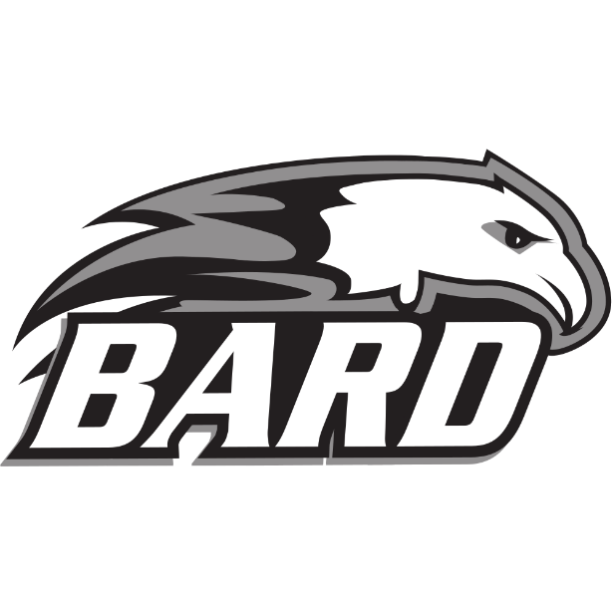
Parent/ Guardian Signature Date
For questions or to schedule an interview, please contact:
BHSEC Cleveland Admissions
Nathaniel Austin
Phone: (216) 838- 9718
Email: naustin@bhsec.bard.edu
Admissions Checklist
Please include the following items to ensure your application is complete.
- Completed application

- Copy of grades for the past two academic years (including attendance)

- One Letter of Recommendation (optional)

- State Test Scores

